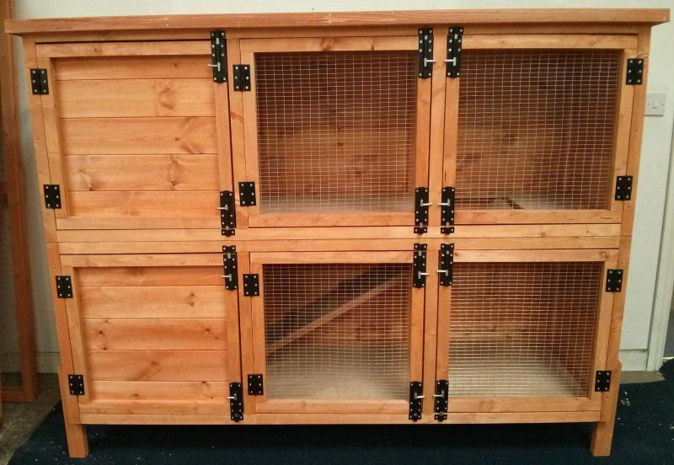

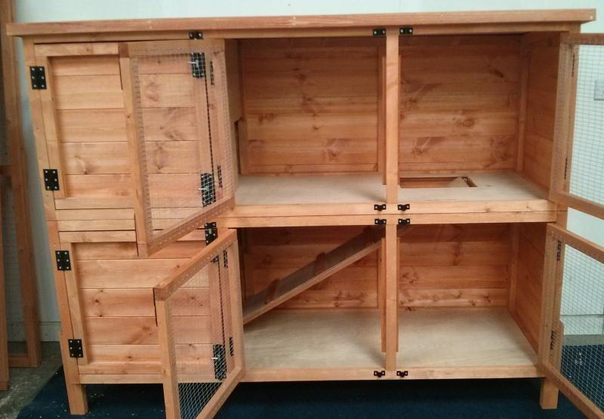
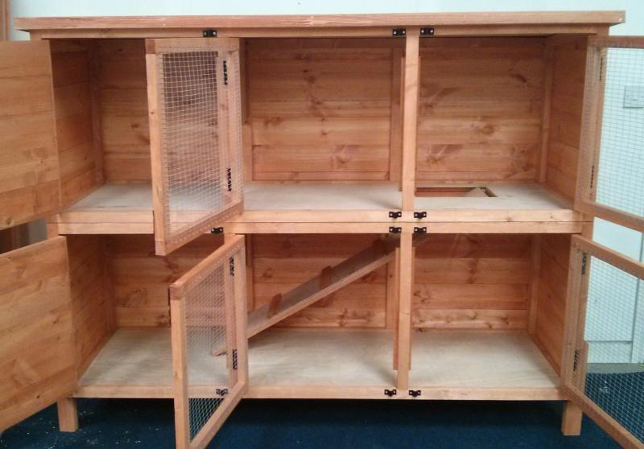 6ft Double Storey Rabbit Hutch

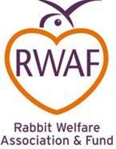 | Rabbit Welfare Association and Fund  Approved Rabbit Hutch
DIMENSIONS:
Overall dimensions including roof
Centimetres - 191cm wide x 65cm deep x 140cm high
Feet and inches - 6ft 3" wide x 2ft 2" deep x 4ft 8" high
Note, measurements are to the nearest inch
SPECIAL FEATURES
This hutch has several benefits that make it stand out from the rest.
The felt used is a premium grade felt that will last 2 or 3 times that of standard hutch felt.
Both the floor and roof is made from high grade WBP external hard wearing plywood with a smooth veneered surface for easy cleaning
All doors are secured by two 4" powder coated barrel bolts to provide additional security from predators
The sides and back of the hutch are constructed from premium Redwood thick T & G cladding to provide a solid structure
DETAILS:
Our large 6ft double rabbit hutches are made from high quality materials, provide easy maintenance and are RWAF approved. Here are some of the other benefits of these hutches:
- Manufactured in the UK
- Conforms to the requirements of the Rabbit Welfare Association
- High grade fox proof barrel bolts
- All wood is preserved with animal friendly preservative
- All hutches are flat packed with doors, hinges, barrel bolts all pre-fitted to ensure simple assembly
- Galvanised mesh doors
This hutch has four mesh doors that open to provide full and easy access to the whole exercise area. This will allow easy cleaning and access to your pets.
There are two solid doors that give access to the sleeping areas that are partitioned from the exercise areas but allow access to it through an access door. A ramp can be provided as an option to provide access between the two floors.
It is suitable for rescue rabbits or bunnies that have outgrown their existing hutch or need to be separated for a reason.
The hutch is raised off the ground by 6” so it is kept dry
DELIVERY:
Delivery lead time for this hutch is currently 2-3 weeks.
CUSTOM DESIGN:
We are more than happy to change our dimensions and designs to fit your exact requirements. Please contact us HERE and let us know what you require and we will do our best to accommodate you